A MAJOR PROJECT REPORT ON

**“Airline Reservation System”**

Submitted in partial fulfillment of the requirements for the Award of Degree of **Bachelor of Computer Application.**

**2012-2015**

**Submitted by: Under the Guidance of:**

**Rohit Sharma Santanoo Pattnaik**

**Paramjot Singh**



**BHARATI VIDYAPEETH DEEMED UNIVERSITY, PUNE (INDIA)**  
School of Distance Education (SDE)  
Academic Study Center : BVIMR, New Delhi

# STUDENT UNDERTAKING

We **“Rohit Sharma”** and **“Paramjot Singh”** have completed the Project **”Airline Reservation System”** under the guidance of “**Mr. Santanoo Pattnaik ”** in the partial fulfillment of the requirement for the award of degree of **Bachelor of Computer Applications** of BVU**, SDE, Academic Study Center BVIMR, New Delhi**.   This is an original piece of work & we have neither copied and nor submitted it earlier elsewhere.

**Students Name and Signature:**

**Course:**

**PREFACE**

The satisfaction that accompany successful completion of any work would be incomplete without the mention of people who made it possible.

Primarily, we would like to thank our institute **BHARTI VIDYAPEETH UNIVERSITY INSTITUTE OF MANAGEMENT & RESEARCH** and also other staff members for giving us the opportunity to fulfill our aspiration.

We are thankful to our program guide, **MR.SANTANOO PATTNAIK sir,** for their valuable guidance and remarkable patience in guiding our work to its fulfillment, we wish to thank our parents for their constant encouragement which is like snow, softer when it falls and longer when it dwells upon, the deeper it sinks in mind.

We will be failing in our mission if we do not thank other people who directly or indirectly helped us in the successful completion of the project. So, our heartful thanks to all friends & staff of my college, who supported and encouraged us in preparing this project report as best as possible.

**ACKNOWLEDGEMENT**

It is the matter of great pleasure and privilege to be able to present this project report on **Airline Reservation System.** The compilation of the project is a milestone in the life of the management student and its execution is inevitable with the co-operation of the project guide. We wish to record a deep sense of respect and gratitude to ou**r project guide , MR.SANTANOO PATTNAIK SIR**  for his encouragement to course of our work. It is due to the endurement effort and guidance of our guide that ultimately made it success.

We also take this opportunity to express the valuable opportunity give to us by the **BHARTI VIDYAPEETH DEEMED UNIVERSITY , PUNE(INDIA) SCHOOL OF DISTANCE EDUCATION (SDE) ACADEMIC CENTER: BVIMR NEW DELHI** for our views.

It is our proud privilege to express our deep sense of appreciation and gratitude to our **PARENTS AND FRIENDS** for their support and co-operation in the course of the project either directly or indirectly involved in time with their valuable contribution.

**TABLE OF CONTENTS**

**CHAPTER 1**

**INTRODUCTION**

1.1    Introduction   
1.2     Introduction About Project 1.3    Present state of the art  
1.4     Need of Computerization of System  
1.5     Proposed Software (What would s/w accomplish)  
1.6      Importance of the Work

**CHAPTER 2**

**SYSTEM ANALYSIS**

2.1 Feasibility Study of Project includes its types

2.2 Analysis Methodology (Types)

2.3 Choice of Platforms s/w & h/w

2.3.1 Software used

2.3.2 Hardware used

**CHAPTER 3**

**SYSTEM DESIGN**

3.1 Design methodology    3.2 Database design 3.3 Screen Design  
3.4      Report design

(Include DFD/ERD/OOAD/Screen shots /reports& data base design)       

**CHAPTER 4**

**TESTING AND IMPLEMENTATION**

4.1 Testing Methodology (Types)

4.2 Unit Testing

4.3 Module Testing

4.4 System Testing

4.5 Alpha/Beta Testing

4.6 White Box Black Box Testing

4.7 Implementation

4.8 Post Implementation

**CHAPTER 5**

**CONCLUSION AND REFERENCES**

5.1      Conclusion

5.2.1 H/W Requirement

5.2.2   S/W Requirement

**CHAPTER 1**

**INTRODUCTION**

* 1. Introduction about Project
  2. Present state of the art
  3. Need of computerization system
  4. Proposed Software (What would s/w accomplish)
  5. Importance of the Work

**1.1 Introduction**

This project is developed with an aim that the Passengers would be able to book their flight in a very systematic manner through this software which is a very feasible one in all the aspects.

While making this project, the security issue was kept in mind due to which this project is very proficient as far as security is concerned. This project prompts for a password while dealing with delicate information which makes it very powerful regarding the security issues.

**OBJECTIVE**

**The main idea of developing this project is to provide the facility for ticket booker to book their flight without going anywhere. The main purpose behind this project is to provide the facility or environment of Airport by sitting at home or office to the booker. The booker can book his personally sitting at the chair. Booker do not have to go airport to book a flight .This idea will save his time & money both.**

**Scope**

Although, it will not be so much advanced like the other softwares but yet it is very much effective and works like the advanced and automated softwares available in the market.

# Also , it will be available free of cost on the internet.

**1.2 Present state of the art**

# Nowadays, the flights are being booked online so as such there is no requirement of these kind of soft wares but however if someone wants to maintain a record of flights on his own end then this software is like an asset for him as it is very secure and provides a lot of facilities to the users which are not even provided by the different Projects.

# ****1.3 Proposed software (what would s/w accomplish)****

# In this process fully time saving of the user and the Reduce the work to go and fulfilling the a**pplication form manually.**

**1.4 IMPORTANCE OF THE WORK**

* Information of flights without going here and there.
* Availability of information of various years in one place in the form of databases in CD ROM , Hard disks.
* Reduce stress through automation.

**CHAPTER 2**

2.1      Feasibility Study and its types

2.2      Analysis Methodology (Types)

2.3      Choice of Platforms s/w & h/w

2.3.1   Software used

2.3.2   Hardware used

# 2.1      Feasibility Study and its types

The basic purpose of feasibility study or survey is to determine whether the whole process of system analysis leading to

Computerization would be worth the effort for the organization.

A Project would take the place of the expense, hassle, and delays of product brochures. The link will point potential users to the link. As new features are added, site visitors would see them listed.

Feasibility study asks whether the managements’ concept of their desired new system is actually an achievable, realistic goal, in terms of money, time and end result difference to the original system. Often, it may be decided to simply update an existing system, rather than to completely replace one. In booking of flights co**ncern** is a conundrum -- the project requires the very technology offered to potential customers -- web access. If people can get on the web, they wouldn't need the site.

However, the project is also intended to motivate and coordinate volunteers (staff), to serve the administrative aspects of the organization.

The feasibility study results in the preparation of a report called the Feasibility Study/ Survey Report, which is submitted to the management for consideration. It contains the following details:

A proposed solution to the problem .

Rough estimate on the cost/benefits analysis if the solution is implemented

Approximate time, effort and cost estimates for completion of the project

# TYPES OF FEASIBILTY STUDY:-

Economical Feasibility

Technical Feasibility

Operational Feasibility

Behavioral Feasibility

# ECONOMICAL FEASIBILITY

Economical analysis is the most frequently used method for evaluating the effectiveness of the new Project most commonly known as cost/benefit analysis. It is the procedure to determine the benefits and savings that are expected from the new Project and compare them with costs. If benefits overweigh costs, then the decision is made to design and implement the new Project. Otherwise, further justification or alternations in the proposed system will have to be made if it is to have a change of being approved.

In developing cost estimates for the Project, we need to consider several cost elements. Among them are:-

**Hardware Costs:-** relate to the actual purchase or lease of the computer and peripherals like printer, disk drive, tape unit etc.

**Facility Costs:-** All one time costs are expenses incurred in the preparation of the physical site where the application or the computer will be in operation.

**Supply Costs:-** are available costs that increase with the increased use of paper, and the like.

# TECHNICAL FEASIBILITY

It is related to the software and equipment specified in design for implementing the new system. It confirms that the necessary technology .i.e. required for the proposed system exists in the organization. The issues involved are:-

**Matching the configuration requirements:** Checking if the suggested solution will be supported by the existing technology, whether it is capable of sorting the volumes of data and meeting the further requirements related to the H/w and S/w.

**Making the project secure:** The project should be secure enough so that no one can make use the information of the organization in a wrong or negative manner.

# OPERATIONAL FEASIBILITY

It is mainly related to human organizational and political aspects. Not only must an application make economic and technical sense, it must also make operational sense. The basic question that you are trying to answer is, “it is possible to maintain and support this application once it is in production?”

Building an application is decidedly different than operating it, therefore you need to determine whether or not you can effectively operate and support it. The new and young staff do understand the need of such change in Project.

With the new project there will be no job-cutting process will be done. Rather, the organization is expecting that through the new Project more and more people become aware of it and hence new applicants for various job profiles will approach. The new project will at some amount reduce paper work they have to do everyday. The task distribution will remain the same.

There will not be a need of making all the staff members to teach a certain new skill to work on the new Project as working on the world wide web is a kids play now a days.

# BEHAVIOURIAL FEASIBILITY

The project is behaviorally feasible. People are inherently resistant to change and computers are known to facilitate changes. An estimate should be made on how strong reaction the user staff is likely to have towards the development. The system is mainly of use of the staff who will make necessary changes and updated as and when required and the people who will access the World Wide Web.

**Details:**

There was an internal survey and analysis is done regarding how the latter thinks about the new project proposal and to this the response was in the favor of the proposal.

# 2.2      Analysis Methodology (Types)

System analysis is the most important phase in a system development. In this phase, the new project to be prepared is fully analyzed in all aspects. Analysis is actually a detailed study of the various operations performed by a system and their relationships within and outside the system.

A key question is: what must be done to solve the problem?One aspect of analysis is defining the boundaries of the system and determining whether or not the project should consider other related systems.

During analysis, data are collected on the available files, decision points handled by the present Project. Some logical system models and tools that are used in analysis (Data flow diagrams, interviews) are commonly used tools in analysis. It requires special skills and sensitivity to the subjects being interviewed. Bias in data collection and interpretations can be a problem. Training, experience and common sense are required for collection of the information needed to the analysis.

Once analysis is completed, the analyst has a firm understanding of what is to be done the next step is to decide how the problem might be solved. Thus, in a system design we move from the logical to the physical aspects of the life cycle.

**2.3      Choice of Platforms s/w & h/w**

**Software** is a general term used to describe a collection of computer programs procedures, and documentation that perform some tasks on a computer system. Practical computer systems divide software systems into three major classes:system software, programming, software, and application software, although the distinction is arbitrary and often blurred. Software is an ordered sequence of instructions for changing the state of the computer hardware in a particular sequence. It is usually written in high-level programming languages that are easier and more  efficient  for humans to use (closer to natural language) than machine language. High-level languages are compiled or interpreted into machine language object code. Software may also be written in an assembly language, essentially, a mnemonic representation of a machine language using a natural language alphabet.

Hardware is best described as a device that is physically connected to the computer or something that can be physically touched. A CD-ROM, monitor printer, and video card are all examples of computer hardware. Without any hardware your computer would not exist and software would have nothing to run on. It is the physical part of a computer, including the digital circuitry, as distinguished from the computer software that executes within the hardware.

# 2.3.1 Software used

# Operating System : Windows 7

# Front end : Visual basic 6.0

Backend : MS Access 7.0

# 2.3.2   H/W REQUIREMENT

The hardware requirements needed to run this system both server and client configurations are as follows

Processor : Intel® Dual core™ cpu@2.30GHz

RAM : 512 MB

Hard Disk : 40 GB

Printer : Laser Printer

**CHAPTER 3**

**SYSTEM DESIGN**

3.1 Design methodology        3.2 Menu flow diagram 3.3 Data flow diagram  
3.4      Screen Design with coding          

# 3.1   DESIGN METHODOLOGY

Design is the first step into the development phase for engineered product or system. Design is a creative process. A good design is the key to effective system. The term “design” is defined as “the process of applying various techniques and principles for the purpose of defining a process or a system in sufficient detail to permit in physical realization”. It may be defines as a process of applying various techniques and principles for the purpose of defining a device , a process or a system detail to permit its physical realization. Software design sits at the technical kernel of the software engineering process and is applied regardless of the development paradigm that is used. The system design develops the architectural detail required to build a system or product. As in the case of any systematic approach, this software too has undergone the best possible design phase fine tuning all efficiency , performance and accuracy levels. The design phase is a transition from a user oriented document to a document to the programmers or database personnel.

The term ‘design’ describes a final system, and the process by which it is developed. It refers to the technical specifications (like blueprints) that will be applied in implementing the Project. Hence, it signifies how the project will meet the requirements which were specified during system analysis.

Design is a creative process requiring insight and flair on the pert of the designer. It must be practiced and learnt by experience and study of existing systems.

Any design problem must be tackled in three stages:

* Study and understand the problem
* Identify gross features of at least one possible solution
* Describe each abstraction used in the solution

**The progression from an informal to a detailed design**

Informal design outline

Informal design

More formal design

**Finished Design**

Figure 3.1

Book Your Flight

Check Your Flight Status

LOGIN /

SIGN UP

Airline Reservation System

Feedback

Help

About Developers

**ERD ( Entity Relationship Diagram )**

ADMIN

HANDLES

TICKETS

POSSESSED BY

Passenger

**DFD ( Data Flow Diagram )**

Passenger

Airline Reservation System

**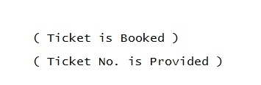**

**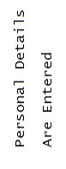** Details Are Stored in

Database ( Flight Details &

Passenger’s Details )

**3.4 Screen design with coding**

**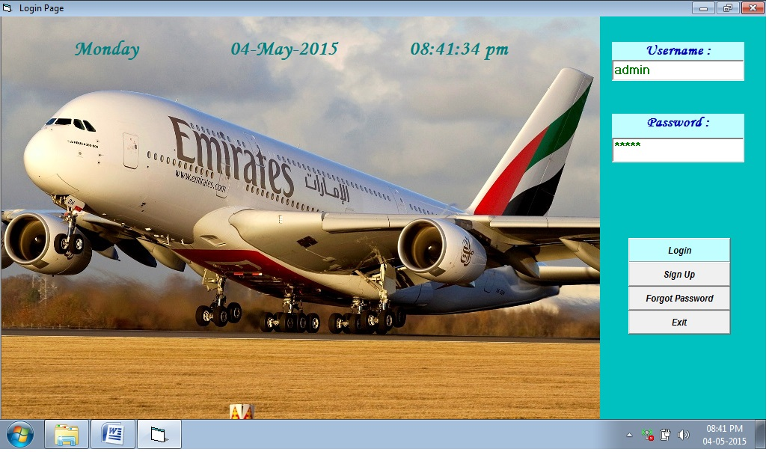**

**LOGIN FORM**

Private Sub Command1\_Click()

con.ConnectionString = "provider=microsoft.jet.oledb.4.0;data source=" & App.Path & "\airticket.mdb"

con.Open

rst.Open "select max(userial) from ulog", con, adOpenDynamic, adLockOptimistic, adCmdText

X = 1 + rst(0)

rst.Close

rst2.Open "select count(\*) from aircust where uname=' " & Text1.Text & " ' and upass=' " & Text2.Text & " '", con, adOpenDynamic, adLockOptimistic, adCmdText

rst3.Open "select uname,upass from aircust where uname=' " & Text1.Text & " ' and upass=' " & Text2.Text & " '", con, adOpenDynamic, adLockOptimistic, adCmdText

rst4.Open "select count(\*) from aircust where uname=' " & Text1.Text & " '", con, adOpenDynamic, adLockOptimistic, adCmdText

If Text1.Text = "" And Text2.Text = "" Then

MsgBox "Please Type Username & Password", vbExclamation, "Airline Reservation System"

Text1.SetFocus

rst2.Close

rst3.Close

rst4.Close

con.Close

ElseIf Text1.Text = "" Then

MsgBox "Please Type Username", vbExclamation, "Airline Reservation System"

Text1.SetFocus

rst2.Close

rst3.Close

rst4.Close

con.Close

ElseIf Text2.Text = "" Then

MsgBox "Please Type Password", vbExclamation, "Airline Reservation System"

rst2.Close

rst3.Close

rst4.Close

con.Close

Text2.SetFocus

ElseIf Text1.Text = "admin" And Text2.Text = "rohit" Then

con.Execute ("insert into ulog values(' " & X & " ',' " & Text1.Text & " ',' " & Text2.Text & " ',' " & Now & " ',' " & Format(Now, "dddd") & " ',' Administrator ')")

MsgBox "Login Successful", vbInformation, "Airline Reservation System"

ElseIf Val(rst4(0)) > 0 Then

If Val(rst2(0)) = 0 Then

MsgBox "Invalid Password", vbExclamation, "Airline Reservation System"

Else: MsgBox "Login Successful", vbInformation, "Airline Reservation System"

con.Execute ("insert into ulog values(' " & X & " ',' " & Text1.Text & " ',' " & Text2.Text & " ',' " & Now & " ',' " & Format(Now, "dddd") & " ',' Local User ')")

ElseIf Val(rst4(0)) = 0 Then

MsgBox "Invalid Username", vbExclamation, "Airline Reservation System"

Private Sub Command2\_Click()

If MsgBox("Are You Sure You Want To Exit The Project ? ", vbQuestion + vbYesNo, "Airline Reservation System") = vbYes Then

End

End If

End Sub

Private Sub Timer1\_Timer()

Label3.Caption = Format(Now, "dddd")

Label4.Caption = Format(Now, "dd-mmm-yyyy")

Label5.Caption = Format(Now, "hh:mm:ss am/pm")

End Sub

**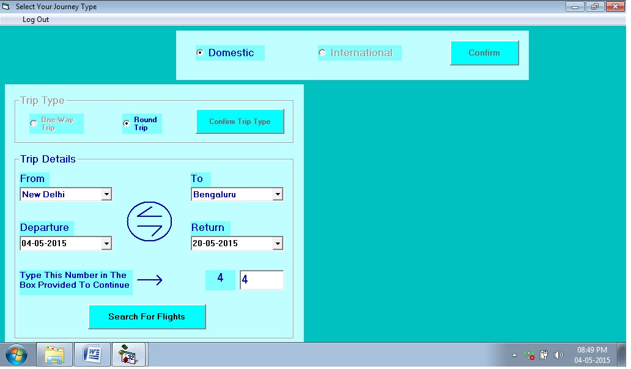**

**Select Your Journey Type**

Dim b As String

Private Sub Command4\_Click()

b = Text2.Text

If Option7.Value = True Then

If (MsgBox("Are You Sure You Want To Save Your Details and Continue ?", vbYesNo + vbQuestion, "Airline Reservation System") = vbYes) Then

If StrComp(Combo11.Text, Combo12.Text) = 0 Or Len(Combo11.Text) = 0 Or Len(Combo12.Text) = 0 Then

MsgBox "Both The Places Can't Be Same or Left Blanked", vbCritical, "Airline Reservation System"

ElseIf StrComp(DTPicker3.Value, Format(Now, "dd-mm-yyyy")) < 0 Then

MsgBox "Historical Date in Departure Field is Not Allowed", vbCritical, "Airline Reservation System"

ElseIf Len(Trim(Text2.Text)) = 0 Then

MsgBox "Please Type The Number", vbCritical, "Airline Reservation System"

ElseIf StrComp(Label12.Caption, Text2.Text) <> 0 Then

MsgBox "Incorrect Number Typed", vbCritical, "Airline Reservation System"

Text2.Text = Clear

Text2.SetFocus

Else: con.ConnectionString = "provider=microsoft.jet.oledb.4.0;data source=" & App.Path & "\airticket.mdb"

con.Open

con.Execute ("insert into intone values(' " & Text2.Text & " ',' ARSIOW' & '" & b & " ',' " & Option7.Caption & " ' , ' " & Combo11.Text & " ' , ' " & Combo12.Text & " ' , ' " & DTPicker3.Value & " ')")

MsgBox "Your Details Were Successfully Stored.", vbInformation, "Airline Reservation System"

con.Close

Form9.Show

Unload Me

End If

Else: MsgBox "Your Details Were Not Submitted.", vbCritical, "Airline Reservation System"

End If

ElseIf Option3.Value = True Then

If (MsgBox("Are You Sure You Want To Save Your Details and Continue ?", vbYesNo + vbQuestion, "Airline Reservation System") = vbYes) Then

If StrComp(Combo11.Text, Combo12.Text) = 0 Or Len(Combo11.Text) = 0 Or Len(Combo12.Text) = 0 Then

MsgBox "Both The Places Can't Be Same or Left Blanked", vbCritical, "Airline Reservation System"

ElseIf StrComp(DTPicker3.Value, Format(Now, "dd-mm-yyyy")) < 0 Then

MsgBox "Historical Date in Departure Field is Not Allowed", vbCritical, "Airline Reservation System"

ElseIf StrComp(Format(DTPicker4.Value, "dd-mm-yyyy"), Format(DTPicker3.Value, "dd-mm-yyyy")) < 0 Or StrComp(Format(DTPicker4.Value, "yyyy"), Format(DTPicker3.Value, "yyyy")) < 0 Then

MsgBox "Return Date Can't Be Earlier Than Departure Date", vbCritical, "Airline Reservation System"

ElseIf Len(Trim(Text2.Text)) = 0 Then

MsgBox "Please Type The Number", vbCritical, "Airline Reservation System"

ElseIf StrComp(Label14.Caption, Text2.Text) <> 0 Then

MsgBox "Incorrect Number Typed", vbCritical, "Airline Reservation System"

Text2.Text = Clear

Text2.SetFocus

Else: con.ConnectionString = "provider=microsoft.jet.oledb.4.0;data source=" & App.Path & "\airticket.mdb"

con.Open

con.Execute ("insert into intround values(' " & Text2.Text & " ',' ARSIRT' & '" & b & " ',' " & Option3.Caption & " ' , ' " & Combo11.Text & " ' , ' " & Combo12.Text & " ' , ' " & DTPicker3.Value & " ' , ' " & DTPicker4.Value & " ')")

MsgBox "Your Details Were Successfully Stored.", vbInformation, "Airline Reservation System"

con.Close

Form92.Show

Unload Me

End If

Else: MsgBox "Your Details Were Not Submitted.", vbCritical, "Airline Reservation System"

End If

End If

End Sub

Private Sub Command5\_Click()

a = Text1.Text

If Option5.Value = True Then

If (MsgBox("Are You Sure You Want To Save Your Details and Continue ?", vbYesNo + vbQuestion, "Airline Reservation System") = vbYes) Then

If StrComp(Combo1.Text, Combo2.Text) = 0 Or Len(Combo1.Text) = 0 Or Len(Combo2.Text) = 0 Then

MsgBox "Both The Places Can't Be Same or Left Blanked", vbCritical, "Airline Reservation System"

ElseIf StrComp(DTPicker1.Value, Format(Now, "dd-mm-yyyy")) < 0 Then

MsgBox "Historical Date in Departure Field is Not Allowed", vbCritical, "Airline Reservation System"

ElseIf Len(Trim(Text1.Text)) = 0 Then

MsgBox "Please Type The Number", vbCritical, "Airline Reservation System"

ElseIf StrComp(Label9.Caption, Text1.Text) <> 0 Then

MsgBox "Incorrect Number Typed", vbCritical, "Airline Reservation System"

Text1.Text = Clear

Text1.SetFocus

Else: con.ConnectionString = "provider=microsoft.jet.oledb.4.0;data source=" & App.Path & "\airticket.mdb"

con.Open

con.Execute ("insert into domone values(' " & Text1.Text & " ',' ARSDOW' & '" & a & " ',' " & Option5.Caption & " ' , ' " & Combo1.Text & " ' , ' " & Combo2.Text & " ' , ' " & DTPicker1.Value & " ') ")

MsgBox "Your Details Were Successfully Stored.", vbInformation, "Airline Reservation System"

con.Close

Form8.Show

Unload Me

End If

Else: MsgBox "Your Details Were Not Submitted.", vbCritical, "Airline Reservation System"

End If

ElseIf Option6.Value = True Then

If (MsgBox("Are You Sure You Want To Save Your Details and Continue ?", vbYesNo + vbQuestion, "Airline Reservation System") = vbYes) Then

If StrComp(Combo1.Text, Combo2.Text) = 0 Or Len(Combo1.Text) = 0 Or Len(Combo2.Text) = 0 Then

MsgBox "Both The Places Can't Be Same or Left Blanked", vbCritical, "Airline Reservation System"

ElseIf StrComp(DTPicker1.Value, Format(Now, "dd-mm-yyyy")) < 0 Then

MsgBox "Historical Date in Departure Field is Not Allowed", vbCritical, "Airline Reservation System"

ElseIf StrComp(Format(DTPicker2.Value, "dd-mm-yyyy"), Format(DTPicker1.Value, "dd-mm-yyyy")) < 0 Or StrComp(Format(DTPicker2.Value, "yyyy"), Format(DTPicker1.Value, "yyyy")) < 0 Then

MsgBox "Return Date Can't Be Earlier Than Departure Date", vbCritical, "Airline Reservation System"

ElseIf Len(Trim(Text1.Text)) = 0 Then

MsgBox "Please Type The Number", vbCritical, "Airline Reservation System"

ElseIf StrComp(Label13.Caption, Text1.Text) <> 0 Then

MsgBox "Incorrect Number Typed", vbCritical, "Airline Reservation System"

Text1.Text = Clear

Text1.SetFocus

Else: con.ConnectionString = "provider=microsoft.jet.oledb.4.0;data source=" & App.Path & "\airticket.mdb"

con.Open

con.Execute ("insert into domround values(' " & Text1.Text & " ',' ARSDRT' & '" & a & " ',' " & Option6.Caption & " ' , ' " & Combo1.Text & " ' , ' " & Combo2.Text & " ' , ' " & DTPicker1.Value & " ' , ' " & DTPicker2.Value & " ' )")

MsgBox "Your Details Were Successfully Stored.", vbInformation, "Airline Reservation System"

con.Close

Form82.Show

Unload Me

End If

Else: MsgBox "Your Details Were Not Submitted.", vbCritical, "Airline Reservation System"

End If

End If

End Sub

Private Sub Form\_Load()

con.ConnectionString = "provider=microsoft.jet.oledb.4.0;data source=" & App.Path & "\airticket.mdb"

con.Open

rst1.Open "select \* from dom order by domcity", con, adOpenDynamic, adLockOptimistic, adCmdText

rst1.MoveFirst

While rst1.EOF <> True

Combo1.AddItem rst1(0)

Combo2.AddItem rst1(0)

rst1.MoveNext

Wend

rst1.Close

rst2.Open "select \* from intt order by intcity", con, adOpenDynamic, adLockOptimistic, adCmdText

rst2.MoveFirst

While rst2.EOF <> True

Combo12.AddItem rst2(0)

rst2.MoveNext

Wend

rst2.Close

rst2.Open "select \* from dom order by domcity", con, adOpenDynamic, adLockOptimistic, adCmdText

rst2.MoveFirst

While rst2.EOF <> True

Combo11.AddItem rst2(0)

rst2.MoveNext

Wend

rst2.Close

rst3.Open "select max(fno) from domone", con, adOpenDynamic, adLockOptimistic, adCmdText

Label9.Caption = 1 + rst3(0)

rst3.Close

rst3.Open "select max(fno) from domround", con, adOpenDynamic, adLockOptimistic, adCmdText

Label13.Caption = 1 + rst3(0)

rst3.Close

rst3.Open "select max(fno) from intone", con, adOpenDynamic, adLockOptimistic, adCmdText

Label12.Caption = 1 + rst3(0)

rst3.Close

rst3.Open "select max(fno) from intround", con, adOpenDynamic, adLockOptimistic, adCmdText

Label14.Caption = 1 + rst3(0)

rst3.Close

con.Close

End Sub

Private Sub mnuLogOut\_Click()

MsgBox "Successfully Logged Out", vbInformation, "Airline Reservation System"

Form1.Show

Unload Me

End Sub

**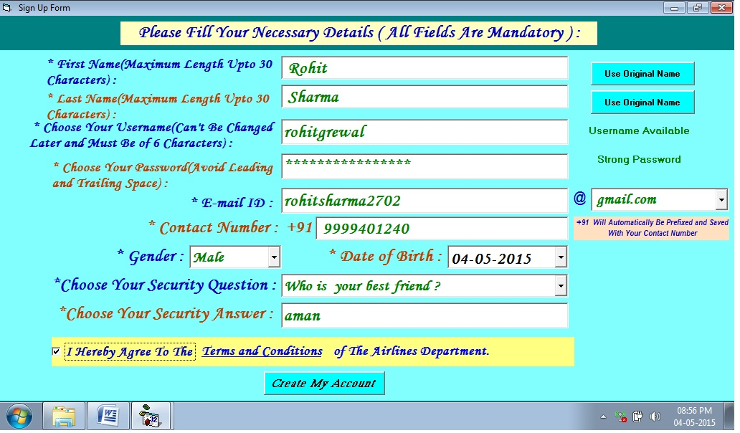**

**SIGN UP FORM**

Private Sub Command1\_Click()

con.ConnectionString = "Provider=Microsoft.Jet.OLEDB.4.0;Data Source=" & App.Path & "\airticket.mdb;"

con.Open

If Len(Trim(Combo1.Text)) > 0 And Len(Trim(Combo2.Text)) > 0 And Len(Trim(Combo3.Text)) > 0 And Len(Trim(MaskEdBox2.Text)) > 0 And Len(Trim(MaskEdBox3.Text)) > 0 And Len(Trim(Text3.Text)) > 0 And Len(Trim(Text4.Text)) > 0 And Len(Trim(MaskEdBox1.Text)) > 0 And Len(Trim(Text6.Text)) > 0 And Len(Trim(Text1.Text)) > 0 Then

rst1.Open "select count(\*) from aircust where uname=' " & Text3.Text & " '", con, adOpenDynamic, adLockOptimistic, adCmdText

If rst1(0) > 0 Then

MsgBox "Username is Not Available", vbCritical, "Airline Reservation System"

Text3.SetFocus

rst1.Close

con.Close

ElseIf Len(Trim(Text3.Text)) < 6 Then

MsgBox "Username Must Be Atleast of 6 Characters", vbCritical, "Airline Reservation System"

Text3.SetFocus

rst1.Close

con.Close

ElseIf StrComp(Right(Trim(Combo3.Text), 4), ".com") <> 0 And StrComp(Right(Trim(Combo3.Text), 6), ".co.in") <> 0 Then

MsgBox "E-mail ID should end with .com or .co.in", vbCritical, "Airline Reservation System"

Combo3.SetFocus

rst1.Close

con.Close

ElseIf Len(Trim(MaskEdBox1.Text)) <> 10 Then

MsgBox "Contact Number Must Be of 10 Digits", vbCritical, "Airline Reservation System"

MaskEdBox1.SetFocus

rst1.Close

con.Close

ElseIf StrComp(DTPicker1.Value, Format(Now, "dd-mm-yyyy")) > 0 Then

MsgBox "Invalid Date of Birth", vbCritical, "Airline Reservation System"

DTPicker1.SetFocus

rst1.Close

con.Close

Else: con.Execute ("insert into aircust values(' " & Trim(MaskEdBox2.Text) & " ',' " & Trim(MaskEdBox3.Text) & " ',' " & Trim(Text3.Text) & " ',' " & Text4.Text & " ',' " & Combo1.Text & " ',' " & DTPicker1.Value & " ',' " & Trim(Text1.Text) & Trim(Label14.Caption) & Trim(Combo3.Text) & " ',' " & Label8.Caption & Trim(MaskEdBox1.Text) & " ',' " & Combo2.Text & " ',' " & Trim(Text6.Text) & " ')")

con.Close

MsgBox "Sign Up Complete.", vbInformation, "Airline Reservation System"

MsgBox "Username : " & Text3.Text & " Password : " & Text4.Text, vbInformation, "Airline Reservation System"

DTPicker1.Enabled = False

Private Sub Command3\_Click()

MaskEdBox2.Text = LCase(Left(MaskEdBox2.Text, 1)) & Mid(MaskEdBox2.Text, 2)

End Sub

Private Sub Command4\_Click()

MaskEdBox3.Text = LCase(Left(MaskEdBox3.Text, 1)) & Mid(MaskEdBox3.Text, 2)

End Sub

Private Sub Form\_Activate()

DTPicker1.Value = Format(Now, "dd-mm-yyyy")

End Sub

Private Sub Form\_Load()

Combo1.AddItem "Male"

Combo1.AddItem "Female"

con.ConnectionString = "Provider=Microsoft.Jet.OLEDB.4.0;Data Source=" & App.Path & "\airticket.mdb;"

con.Open

rst.Open "select sec from q", con, adOpenDynamic, adLockOptimistic, adCmdText

rst.MoveFirst

While rst.EOF <> True

Combo2.AddItem rst(0)

rst.MoveNext

Wend

rst.Close

con.Close

Combo3.AddItem "gmail.com"

Combo3.AddItem "yahoo.com"

Combo3.AddItem "hotmail.com"

Combo3.AddItem "yandex.com"

Combo3.AddItem "Let Me Choose..."

End Sub

Private Sub Label17\_Click()

frmSplash3.Show

End Sub

Private Sub MaskEdBox1\_Change()

If Len(Trim(MaskEdBox1.Text)) < 10 Then

MaskEdBox1.ForeColor = &HFF&

ElseIf Len(Trim(MaskEdBox1.Text)) = 10 Then

MaskEdBox1.ForeColor = &H8000&

End If

End Sub

Private Sub MaskEdBox2\_LostFocus()

MaskEdBox2.Text = UCase(Left(MaskEdBox2.Text, 1)) & Mid(MaskEdBox2.Text, 2)

Command3.Visible = True

End Sub

Private Sub MaskEdBox3\_LostFocus()

MaskEdBox3.Text = UCase(Left(MaskEdBox3.Text, 1)) & Mid(MaskEdBox3.Text, 2)

Command4.Visible = True

End Sub

Private Sub Text3\_Change()

con.ConnectionString = "Provider=Microsoft.Jet.OLEDB.4.0;Data Source=" & App.Path & "\airticket.mdb;"

con.Open

rst.Open "select count(\*) from aircust where uname = ' " & Text3.Text & " '", con, adOpenDynamic, adLockOptimistic, adCmdText

If rst(0) > 0 Then

Label12.Caption = "Username Not Available"

Label12.ForeColor = &HFF&

Text3.ForeColor = &HFF&

Else: Label12.Caption = "Username Available"

If Len(Trim(Text3.Text)) < 6 Then

Label12.Caption = "Username Must Be Atleast of 6 Characters"

Label12.ForeColor = &HFF&

Text3.ForeColor = &HFF&

Else: Label12.ForeColor = &H8000&

Text3.ForeColor = &H8000&

End If

End If

rst.Close

con.Close

End Sub

Private Sub Text3\_GotFocus()

If Len(Trim(Text3.Text)) = 0 Then

Label12.Caption = "\*Make Sure That Your Username is Unique"

End If

End Sub

Private Sub Text3\_LostFocus()

If Len(Trim(Text3.Text)) = 0 Then

Label12.Caption = Clear

End If

End Sub

Private Sub Text4\_Change()

If Len(Trim(Text4.Text)) > 10 Then

Label11.Caption = "Strong Password"

Label11.ForeColor = &H8000&

Text4.ForeColor = &H8000&

ElseIf Len(Trim(Text4.Text)) > 7 Then

Label11.Caption = "Fair Password"

Label11.ForeColor = &HFF0000

Text4.ForeColor = &HFF0000

Else: Label11.Caption = "Weak Password"

Label11.ForeColor = &HFF&

Text4.ForeColor = &HFF&

End If

End Sub

Private Sub Text4\_GotFocus()

If Len(Trim(Text4.Text)) = 0 Then

Label11.Caption = "Password Should Contain More Than 7 Characters"

End If

End Sub

Private Sub Text4\_LostFocus()

If Len(Trim(Text4.Text)) = 0 Then

Label11.Caption = Clear

End If

End Sub

**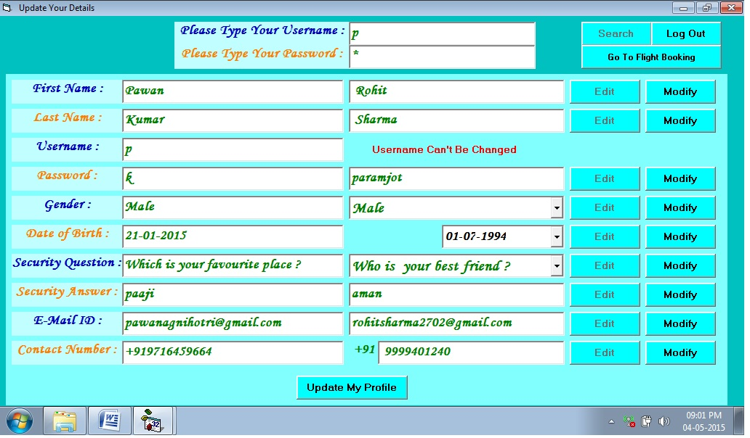**

**Update Your Profile Form**

Private Sub Command1\_Click()

con.Open

rst1.Open "select \* from aircust where uname = ' " & Text10.Text & " ' and upass = ' " & Text11.Text & " '", con, adOpenDynamic, adLockOptimistic, adCmdText

rst2.Open "select count(\*) from aircust where uname=' " & Text10.Text & " ' and upass=' " & Text11.Text & " '", con, adOpenDynamic, adLockOptimistic, adCmdText

rst3.Open "select uname,upass from aircust where uname=' " & Text10.Text & " ' and upass=' " & Text11.Text & " '", con, adOpenDynamic, adLockOptimistic, adCmdText

rst4.Open "select count(\*) from aircust where uname=' " & Text10.Text & " '", con, adOpenDynamic, adLockOptimistic, adCmdText

If Len(Trim(Text10.Text)) = 0 And Len(Trim(Text11.Text)) = 0 Then

MsgBox "Please Enter Username and Password", vbCritical, "Airline Reservation System"

Text10.SetFocus

rst1.Close

rst2.Close

rst3.Close

rst4.Close

con.Close

ElseIf Len(Trim(Text10.Text)) = 0 Then

MsgBox "Please Enter Username", vbCritical, "Airline Reservation System"

Text10.Text = Clear

Text10.SetFocus

rst1.Close

rst2.Close

rst3.Close

rst4.Close

con.Close

ElseIf Len(Trim(Text11.Text)) = 0 Then

MsgBox "Please Enter Password", vbCritical, "Airline Reservation System"

Text11.Text = Clear

Text11.SetFocus

rst1.Close

rst2.Close

rst3.Close

rst4.Close

con.Close

ElseIf Val(rst4(0)) > 0 Then

If Val(rst2(0)) = 0 Then

MsgBox "Invalid Password", vbExclamation, "Airline Reservation System"

rst1.Close

rst2.Close

rst3.Close

rst4.Close

con.Close

Text11.Text = Clear

Text11.SetFocus

Else: Frame1.Visible = True

Text1.SetFocus

Text1.Text = Trim(rst1!ufirst)

Text2.Text = Trim(rst1!ulast)

Text3.Text = Trim(rst1!uname)

Text4.Text = Trim(rst1!upass)

Text5.Text = Trim(rst1!ugender)

Text6.Text = Trim(rst1!umail)

Text7.Text = Trim(rst1!uphone)

Text8.Text = Trim(rst1!usec)

Text9.Text = Trim(rst1!uans)

Text12.Text = Trim(rst1!udob)

rst1.Close

rst2.Close

rst3.Close

rst4.Close

con.Close

Command1.Enabled = False

Text10.Locked = True

Text11.Locked = True

End If

ElseIf Val(rst4(0)) = 0 Then

MsgBox "Invalid Username", vbExclamation, "Airline Reservation System"

End If

End Sub

Private Sub Command21\_Click()

If StrComp(DTPicker1.Value, Format(Now, "dd-mm-yyyy")) > 0 Then

MsgBox "Invalid Date of Birth", vbCritical, "Airline Reservation System"

con.Close

ElseIf MsgBox("Are You Sure You Want To Save The Changes", vbYesNo + vbQuestion, "Airline Reservation System") = vbYes Then

con.Execute ("update aircust set ufirst = ' " & Text1.Text & " ' where uname = ' " & Text3.Text & " '")

con.Execute ("update aircust set ulast = ' " & Text2.Text & " ' where uname = ' " & Text3.Text & " '")

con.Execute ("update aircust set upass = ' " & Text4.Text & " ' where uname = ' " & Text3.Text & " '")

con.Execute ("update aircust set ugender = ' " & Text5.Text & " ' where uname = ' " & Text3.Text & " '")

con.Execute ("update aircust set udob = ' " & Text12.Text & " ' where uname = ' " & Text3.Text & " '")

con.Execute ("update aircust set usec = ' " & Text8.Text & " ' where uname = ' " & Text3.Text & " '")

con.Execute ("update aircust set uans = ' " & Text9.Text & " ' where uname = ' " & Text3.Text & " '")

con.Execute ("update aircust set umail = ' " & Text6.Text & " ' where uname = ' " & Text3.Text & " '")

con.Execute ("update aircust set uphone = ' " & Text7.Text & " ' where uname = ' " & Text3.Text & " '")

MsgBox "Profile Successfully Updated", vbInformation, "Airline Reservation System"

Frame1.Visible = False

Command1.Enabled = True

Text10.Locked = False

Text11.Locked = False

con.Close

Else: con.Close

End If

Else: MsgBox "You Can't Leave Any Mandatory Field Blank", vbCritical, "Airline Reservation System"

con.Close

End If

End Sub

Private Sub Form\_Load()

con.ConnectionString = "Provider=Microsoft.Jet.OLEDB.4.0;Data Source=" & App.Path & "\airticket.mdb;"

con.Open

rst1.Open "select \* from q", con, adOpenDynamic, adLockOptimistic, adCmdText

rst1.MoveFirst

While rst1.EOF <> True

Combo2.AddItem rst1(0)

rst1.MoveNext

Wend

rst1.Close

con.Close

Combo1.AddItem "Male"

Combo1.AddItem "Female"

End Sub

**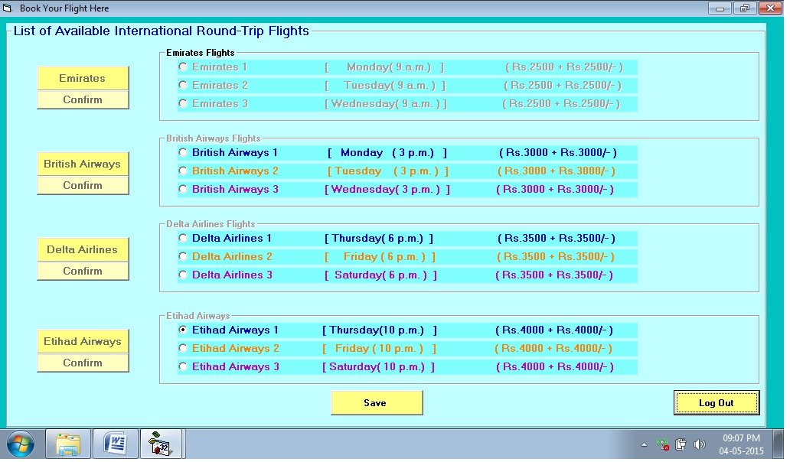**

**Book Your Flight Here**

Dim n As String

Private Sub Command10\_Click()

MsgBox "Your Flight is Successfully Booked.", vbInformation, "Airline Reservation System"

Form2.Show

Unload Me

End Sub

Private Sub Command6\_Click()

If Option1.Value = True Then

If (MsgBox("Are You Sure You Want To Confirm Your Flight ?", vbYesNo + vbQuestion, "Airline Reservation System") = vbYes) Then

con.ConnectionString = "provider=microsoft.jet.oledb.4.0;data source=" & App.Path & "\airticket.mdb"

con.Open

rst.Open "select max(fno) from confirmintround", con, adOpenDynamic, adLockOptimistic, adCmdText

n = 1 + Val(rst(0))

rst.Close

con.Execute ("insert into confirmintround values(' " & n & " ',' ARSIRT' & '" & n & " ',' Emirates 1 ',' " & Option1.Caption & " ')")

MsgBox "Your Flight Has Been Confirmed", vbInformation, "Airline Reservation System"

rst5.Open "select regno from confirmintround where regno = ' ARSIRT' & '" & n & " '", con, adOpenDynamic, adLockOptimistic, adCmdText

MsgBox "Your Registration Number is : " & rst5(0), vbInformation, "Airline Reservation System"

rst5.Close

con.Close

End If

ElseIf Option2.Value = True Then

If (MsgBox("Are You Sure You Want To Confirm Your Flight ?", vbYesNo + vbQuestion, "Airline Reservation System") = vbYes) Then

con.ConnectionString = "provider=microsoft.jet.oledb.4.0;data source=" & App.Path & "\airticket.mdb"

con.Open

rst.Open "select max(fno) from confirmintround", con, adOpenDynamic, adLockOptimistic, adCmdText

n = 1 + Val(rst(0))

rst.Close

con.Execute ("insert into confirmintround values(' " & n & " ',' ARSIRT' & '" & n & " ',' Emirates 2 ',' " & Option2.Caption & " ')")

MsgBox "Your Flight Has Been Confirmed", vbInformation, "Airline Reservation System"

rst5.Open "select regno from confirmintround where regno = ' ARSIRT' & '" & n & " '", con, adOpenDynamic, adLockOptimistic, adCmdText

MsgBox "Your Registration Number is : " & rst5(0), vbInformation, "Airline Reservation System"

rst5.Close

con.Close

End If

ElseIf Option3.Value = True Then

If (MsgBox("Are You Sure You Want To Confirm Your Flight ?", vbYesNo + vbQuestion, "Airline Reservation System") = vbYes) Then

con.ConnectionString = "provider=microsoft.jet.oledb.4.0;data source=" & App.Path & "\airticket.mdb"

con.Open

rst.Open "select max(fno) from confirmintround", con, adOpenDynamic, adLockOptimistic, adCmdText

n = 1 + Val(rst(0))

rst.Close

con.Execute ("insert into confirmintround values(' " & n & " ',' ARSIRT' & '" & n & " ',' Emirates 3 ',' " & Option3.Caption & " ')")

MsgBox "Your Flight Has Been Confirmed", vbInformation, "Airline Reservation System"

rst5.Open "select regno from confirmintround where regno = ' ARSIRT' & '" & n & " '", con, adOpenDynamic, adLockOptimistic, adCmdText

MsgBox "Your Registration Number is : " & rst5(0), vbInformation, "Airline Reservation System"

rst5.Close

con.Close

End If

Else: MsgBox "You Have Not Selected Any Flight.", vbCritical, "Airline Reservation System"

End If

End Sub

Private Sub Command7\_Click()

If Option4.Value = True Then

If (MsgBox("Are You Sure You Want To Confirm Your Flight ?", vbYesNo + vbQuestion, "Airline Reservation System") = vbYes) Then

con.ConnectionString = "provider=microsoft.jet.oledb.4.0;data source=" & App.Path & "\airticket.mdb"

con.Open

rst.Open "select max(fno) from confirmintround", con, adOpenDynamic, adLockOptimistic, adCmdText

n = 1 + Val(rst(0))

rst.Close

con.Execute ("insert into confirmintround values(' " & n & " ',' ARSIRT' & '" & n & " ',' British Airways 1 ',' " & Option4.Caption & " ')")

MsgBox "Your Flight Has Been Confirmed", vbInformation, "Airline Reservation System"

rst5.Open "select regno from confirmintround where regno = ' ARSIRT' & '" & n & " '", con, adOpenDynamic, adLockOptimistic, adCmdText

MsgBox "Your Registration Number is : " & rst5(0), vbInformation, "Airline Reservation System"

rst5.Close

con.Close

End If

ElseIf Option5.Value = True Then

If (MsgBox("Are You Sure You Want To Confirm Your Flight ?", vbYesNo + vbQuestion, "Airline Reservation System") = vbYes) Then

con.ConnectionString = "provider=microsoft.jet.oledb.4.0;data source=" & App.Path & "\airticket.mdb"

con.Open

rst.Open "select max(fno) from confirmintround", con, adOpenDynamic, adLockOptimistic, adCmdText

n = 1 + Val(rst(0))

rst.Close

con.Execute ("insert into confirmintround values(' " & n & " ',' ARSIRT' & '" & n & " ',' British Airways 2 ',' " & Option5.Caption & " ')")

MsgBox "Your Flight Has Been Confirmed", vbInformation, "Airline Reservation System"

rst5.Open "select regno from confirmintround where regno = ' ARSIRT' & '" & n & " '", con, adOpenDynamic, adLockOptimistic, adCmdText

MsgBox "Your Registration Number is : " & rst5(0), vbInformation, "Airline Reservation System"

rst5.Close

con.Close

End If

ElseIf Option6.Value = True Then

If (MsgBox("Are You Sure You Want To Confirm Your Flight ?", vbYesNo + vbQuestion, "Airline Reservation System") = vbYes) Then

con.ConnectionString = "provider=microsoft.jet.oledb.4.0;data source=" & App.Path & "\airticket.mdb"

con.Open

rst.Open "select max(fno) from confirmintround", con, adOpenDynamic, adLockOptimistic, adCmdText

n = 1 + Val(rst(0))

rst.Close

con.Execute ("insert into confirmintround values(' " & n & " ',' ARSIRT' & '" & n & " ',' British Airways 3 ',' " & Option6.Caption & " ')")

MsgBox "Your Flight Has Been Confirmed", vbInformation, "Airline Reservation System"

rst5.Open "select regno from confirmintround where regno = ' ARSIRT' & '" & n & " '", con, adOpenDynamic, adLockOptimistic, adCmdText

MsgBox "Your Registration Number is : " & rst5(0), vbInformation, "Airline Reservation System"

rst5.Close

con.Close

End If

Else: MsgBox "You Have Not Selected Any Flight.", vbCritical, "Airline Reservation System"

End If

End Sub

Private Sub Command8\_Click()

If Option7.Value = True Then

If (MsgBox("Are You Sure You Want To Confirm Your Flight ?", vbYesNo + vbQuestion, "Airline Reservation System") = vbYes) Then

con.ConnectionString = "provider=microsoft.jet.oledb.4.0;data source=" & App.Path & "\airticket.mdb"

con.Open

rst.Open "select max(fno) from confirmintround", con, adOpenDynamic, adLockOptimistic, adCmdText

n = 1 + Val(rst(0))

rst.Close

con.Execute ("insert into confirmintround values(' " & n & " ',' ARSIRT' & '" & n & " ',' Delta Airlines 1 ',' " & Option7.Caption & " ')")

MsgBox "Your Flight Has Been Confirmed", vbInformation, "Airline Reservation System"

rst5.Open "select regno from confirmintround where regno = ' ARSIRT' & '" & n & " '", con, adOpenDynamic, adLockOptimistic, adCmdText

MsgBox "Your Registration Number is : " & rst5(0), vbInformation, "Airline Reservation System"

rst5.Close

con.Close

End If

ElseIf Option8.Value = True Then

If (MsgBox("Are You Sure You Want To Confirm Your Flight ?", vbYesNo + vbQuestion, "Airline Reservation System") = vbYes) Then

con.ConnectionString = "provider=microsoft.jet.oledb.4.0;data source=" & App.Path & "\airticket.mdb"

con.Open

rst.Open "select max(fno) from confirmintround", con, adOpenDynamic, adLockOptimistic, adCmdText

n = 1 + Val(rst(0))

rst.Close

con.Execute ("insert into confirmintround values(' " & n & " ',' ARSIRT' & '" & n & " ',' Delta Airlines 2 ',' " & Option8.Caption & " ')")

MsgBox "Your Flight Has Been Confirmed", vbInformation, "Airline Reservation System"

rst5.Open "select regno from confirmintround where regno = ' ARSIRT' & '" & n & " '", con, adOpenDynamic, adLockOptimistic, adCmdText

MsgBox "Your Registration Number is : " & rst5(0), vbInformation, "Airline Reservation System"

rst5.Close

con.Close

End If

ElseIf Option9.Value = True Then

If (MsgBox("Are You Sure You Want To Confirm Your Flight ?", vbYesNo + vbQuestion, "Airline Reservation System") = vbYes) Then

con.ConnectionString = "provider=microsoft.jet.oledb.4.0;data source=" & App.Path & "\airticket.mdb"

con.Open

rst.Open "select max(fno) from confirmintround", con, adOpenDynamic, adLockOptimistic, adCmdText

n = 1 + Val(rst(0))

rst.Close

con.Execute ("insert into confirmintround values(' " & n & " ',' ARSIRT' & '" & n & " ',' Delta Airlines 3 ',' " & Option9.Caption & " ')")

MsgBox "Your Flight Has Been Confirmed", vbInformation, "Airline Reservation System"

rst5.Open "select regno from confirmintround where regno = ' ARSIRT' & '" & n & " '", con, adOpenDynamic, adLockOptimistic, adCmdText

MsgBox "Your Registration Number is : " & rst5(0), vbInformation, "Airline Reservation System"

rst5.Close

con.Close

Else: MsgBox "You Have Not Selected Any Flight.", vbCritical, "Airline Reservation System"

End If

End Sub

Private Sub Command9\_Click()

If Option10.Value = True Then

If (MsgBox("Are You Sure You Want To Confirm Your Flight ?", vbYesNo + vbQuestion, "Airline Reservation System") = vbYes) Then

con.ConnectionString = "provider=microsoft.jet.oledb.4.0;data source=" & App.Path & "\airticket.mdb"

con.Open

rst.Open "select max(fno) from confirmintround", con, adOpenDynamic, adLockOptimistic, adCmdText

n = 1 + Val(rst(0))

rst.Close

con.Execute ("insert into confirmintround values(' " & n & " ',' ARSIRT' & '" & n & " ',' Etihad Airways 1 ',' " & Option10.Caption & " ')")

MsgBox "Your Flight Has Been Confirmed", vbInformation, "Airline Reservation System"

rst5.Open "select regno from confirmintround where regno = ' ARSIRT' & '" & n & " '", con, adOpenDynamic, adLockOptimistic, adCmdText

MsgBox "Your Registration Number is : " & rst5(0), vbInformation, "Airline Reservation System"

rst5.Close

con.Close

ElseIf Option11.Value = True Then

If (MsgBox("Are You Sure You Want To Confirm Your Flight ?", vbYesNo + vbQuestion, "Airline Reservation System") = vbYes) Then

con.ConnectionString = "provider=microsoft.jet.oledb.4.0;data source=" & App.Path & "\airticket.mdb"

con.Open

rst.Open "select max(fno) from confirmintround", con, adOpenDynamic, adLockOptimistic, adCmdText

n = 1 + Val(rst(0))

rst.Close

con.Execute ("insert into confirmintround values(' " & n & " ',' ARSIRT' & '" & n & " ',' Etihad Airways 2 ',' " & Option11.Caption & " ')")

MsgBox "Your Flight Has Been Confirmed", vbInformation, "Airline Reservation System"

rst5.Open "select regno from confirmintround where regno = ' ARSIRT' & '" & n & " '", con, adOpenDynamic, adLockOptimistic, adCmdText

MsgBox "Your Registration Number is : " & rst5(0), vbInformation, "Airline Reservation System"

rst5.Close

con.Close

End If

ElseIf Option12.Value = True Then

If (MsgBox("Are You Sure You Want To Confirm Your Flight ?", vbYesNo + vbQuestion, "Airline Reservation System") = vbYes) Then

con.ConnectionString = "provider=microsoft.jet.oledb.4.0;data source=" & App.Path & "\airticket.mdb"

con.Open

rst.Open "select max(fno) from confirmintround", con, adOpenDynamic, adLockOptimistic, adCmdText

n = 1 + Val(rst(0))

rst.Close

con.Execute ("insert into confirmintround values(' " & n & " ',' ARSIRT' & '" & n & " ',' Etihad Airways 3 ',' " & Option12.Caption & " ')")

MsgBox "Your Flight Has Been Confirmed", vbInformation, "Airline Reservation System"

rst5.Open "select regno from confirmintround where regno = ' ARSIRT' & '" & n & " '", con, adOpenDynamic, adLockOptimistic, adCmdText

MsgBox "Your Registration Number is : " & rst5(0), vbInformation, "Airline Reservation System"

rst5.Close

con.Close

Else: MsgBox "You Have Not Selected Any Flight.", vbCritical, "Airline Reservation System"

End If

End Sub

**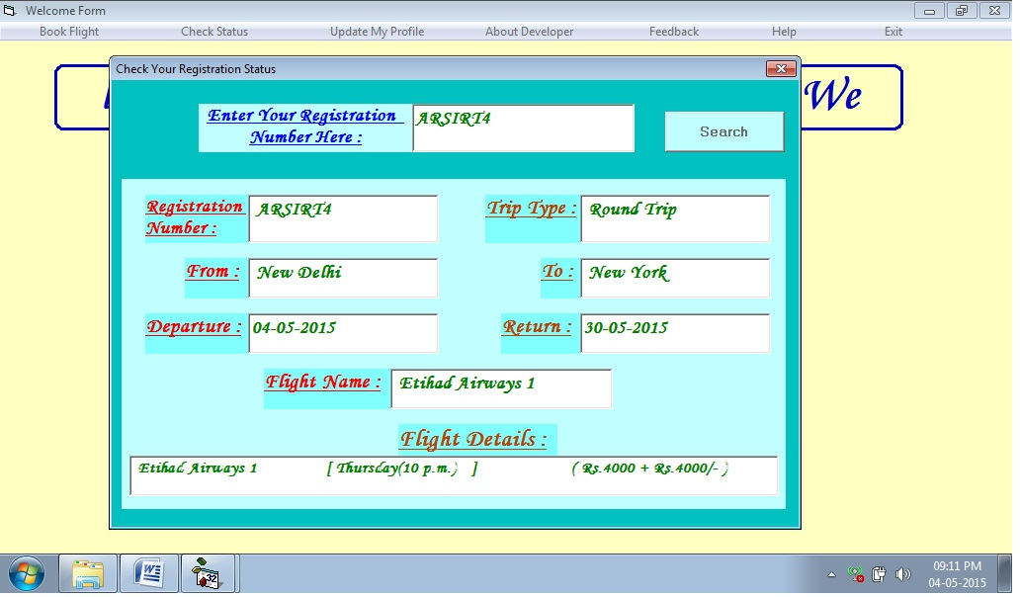**

**Check Your Registration Status**

Private Sub Command1\_Click()

con.Open

If Len(Trim(Text1.Text)) = 0 Then

MsgBox "Please Enter Your Flight Registration Number", vbCritical, "Airline Reservation System"

Text1.SetFocus

con.Close

ElseIf Text1.Text Like "ARSDOW\*" Then

rst5.Open "select count(\*) from domone where regno = ' " & Text1.Text & " '", con, adOpenDynamic, adLockOptimistic, adCmdText

If rst5(0) > 0 Then

MsgBox "Your Flight was Successfully booked", vbInformation, "Airline Reservation System"

rst5.Close

If MsgBox("Do You Want To Check The Details", vbQuestion + vbYesNo, "Airline Reservation System") = vbYes Then

Frame1.Visible = True

Command1.Enabled = False

End If

rst.Open "select \* from domone where regno = ' " & Text1.Text & " '", con, adOpenDynamic, adLockOptimistic, adCmdText

Text2.Text = rst!regno

Text3.Text = rst!triptype

Text4.Text = rst!From

Text5.Text = rst!to

Text6.Text = rst!departure

rst.Close

rst1.Open "select \* from confirmdomone where regno = ' " & Text1.Text & " '", con, adOpenDynamic, adLockOptimistic, adCmdText

Text8.Text = rst1!fname

Text9.Text = rst1!fdetails

rst1.Close

con.Close

Else: MsgBox "Invalid Registration Number", vbCritical, "Airline Reservation System"

Text1.Text = Clear

Text1.SetFocus

rst5.Close

con.Close

End If

ElseIf Text1.Text Like "ARSDRT\*" Then

rst5.Open "select count(\*) from domround where regno = ' " & Text1.Text & " '", con, adOpenDynamic, adLockOptimistic, adCmdText

If rst5(0) > 0 Then

MsgBox "Your Flight was Successfully booked", vbInformation, "Airline Reservation System"

rst5.Close

If MsgBox("Do You Want To Check The Details", vbQuestion + vbYesNo, "Airline Reservation System") = vbYes Then

Frame1.Visible = True

Command1.Enabled = False

End If

rst.Open "select \* from domround where regno = ' " & Text1.Text & " '", con, adOpenDynamic, adLockOptimistic, adCmdText

Text2.Text = rst!regno

Text3.Text = rst!triptype

Text4.Text = rst!From

Text5.Text = rst!to

Text6.Text = rst!departure

Text7.Text = rst!return

rst.Close

rst1.Open "select \* from confirmdomround where regno = ' " & Text1.Text & " '", con, adOpenDynamic, adLockOptimistic, adCmdText

Text8.Text = rst1!fname

Text9.Text = rst1!fdetails

rst1.Close

con.Close

Label7.Visible = True

Text7.Visible = True

Else: MsgBox "Invalid Registration Number", vbCritical, "Airline Reservation System"

Text1.Text = Clear

Text1.SetFocus

rst5.Close

con.Close

End If

ElseIf Text1.Text Like "ARSIOW\*" Then

rst5.Open "select count(\*) from intone where regno = ' " & Text1.Text & " '", con, adOpenDynamic, adLockOptimistic, adCmdText

If rst5(0) > 0 Then

MsgBox "Your Flight was Successfully booked", vbInformation, "Airline Reservation System"

rst5.Close

If MsgBox("Do You Want To Check The Details", vbQuestion + vbYesNo, "Airline Reservation System") = vbYes Then

Frame1.Visible = True

Command1.Enabled = False

End If

rst.Open "select \* from intone where regno = ' " & Text1.Text & " '", con, adOpenDynamic, adLockOptimistic, adCmdText

Text2.Text = rst!regno

Text3.Text = rst!triptype

Text4.Text = rst!From

Text5.Text = rst!to

Text6.Text = rst!departure

rst.Close

rst1.Open "select \* from confirmintone where regno = ' " & Text1.Text & " '", con, adOpenDynamic, adLockOptimistic, adCmdText

Text8.Text = rst1!fname

Text9.Text = rst1!fdetails

rst1.Close

con.Close

Else: MsgBox "Invalid Registration Number", vbCritical, "Airline Reservation System"

Text1.Text = Clear

Text1.SetFocus

rst5.Close

con.Close

End If

ElseIf Text1.Text Like "ARSIRT\*" Then

rst5.Open "select count(\*) from intround where regno = ' " & Text1.Text & " '", con, adOpenDynamic, adLockOptimistic, adCmdText

If rst5(0) > 0 Then

MsgBox "Your Flight was Successfully booked", vbInformation, "Airline Reservation System"

rst5.Close

If MsgBox("Do You Want To Check The Details", vbQuestion + vbYesNo, "Airline Reservation System") = vbYes Then

Frame1.Visible = True

Command1.Enabled = False

End If

rst.Open "select \* from intround where regno = ' " & Text1.Text & " '", con, adOpenDynamic, adLockOptimistic, adCmdText

Text2.Text = rst!regno

Text3.Text = rst!triptype

Text4.Text = rst!From

Text5.Text = rst!to

Text6.Text = rst!departure

Text7.Text = rst!return

rst.Close

rst1.Open "select \* from confirmintround where regno = ' " & Text1.Text & " '", con, adOpenDynamic, adLockOptimistic, adCmdText

Text8.Text = rst1!fname

Text9.Text = rst1!fdetails

rst1.Close

con.Close

Label7.Visible = True

Text7.Visible = True

Else: MsgBox "Invalid Registration Number", vbCritical, "Airline Reservation System"

Text1.Text = Clear

Text1.SetFocus

rst5.Close

con.Close

End If

Else: MsgBox "Invalid Registration Number", vbCritical, "Airline Reservation System"

Text1.Text = Clear

Text1.SetFocus

con.Close

End If

End Sub

Private Sub Form\_Load()

con.ConnectionString = "provider=microsoft.jet.oledb.4.0;data source=" & App.Path & "\airticket.mdb"

End Sub

**CHAPTER 4**

**TESTING AND IMPLEMENTATION**

4.1 Testing Methodology (Types)

4.2 Unit Testing

4.3 Module Testing

4.4 System Testing

4.5 Alpha/Beta Testing

4.6 White Box Black Box Testing

4.7 Implementation

4.8 Post Implementation

**4.1 TESTING METHODOLOGY ( Types)**

One of the purposes of the testing is to validate and verify the system. Verification means checking the system to ensure that it is doing what the function is supposed to do and Validation means checking to ensure that system is doing what the user wants it to do.

No program or system design is perfect; communication between the user and the designer is not always complete or clear, and time is usually short. The result is errors and more errors. Theoretically, a newly designed system should have all the pieces in working order, but in reality, each piece works independently. Now is the time to put all the pieces into one system and test it to determine whether it meets the user's requirements. This is the best chance to detect and correct errors before the system is implemented. The purpose of system testing is to consider all the likely variations to which it will be subjected and then push the system to its limits. If we implement the system without proper testing then it might cause the problems.

1. Communication between the user and the designer.

2. The programmer's ability to generate a code that reflects

exactly the system specification.

3. The time frame for the design.

Theoretically, a new designed system should have all the pieces in working order, but in reality, each piece works independently. Now is the time to put all the pieces into one system and test it to determine whether it meets the requirements of the user. The process of system testing and the steps taken to validate and prepare a system for final implementation are:

**4.2 UNIT TESTING**

In computer programming, unit testing is a software testing method by which individual units of source code sets of one or more computer program modules together with associated control data, usage procedures, and operating procedures are tested to determine if they are fit for use. Intuitively, one can view a unit as the smallest testable part of an application. In procedural programming, a unit could be an entire module, but it is more commonly an individual function or procedure. In object-oriented programming, a unit is often an entire interface, such as a class, but could be an individual method. Unit tests are short code fragments[[3]](http://en.wikipedia.org/wiki/Unit_testing" \l "cite_note-3) created by programmers or occasionally by white box testers during the development process.

**4.3 MODULE TESTING**

Module testing deals with testing of each module separately. Each module is tested to check whether it works according to the requirement and performs the desired functions. It should work according to the specialization and should provide the right results. Module testing saves a lot of time in defecting errors to a later stage. Module testing was done for the system and modules were found to be working properly.

**STRATEGIC APPROACH TO SOFTWARE TESTING**

The software engineering process can be viewed as a spiral . Initially system engineering defines the role of software and leads to software requirements analysis where the information domain, functions, behavior, performance, constraints and validation criteria for software are established. Moving inward along the spiral, we come to design and finally to coding. To develop computer software We spiral in along streamlines that decrease the level of abstraction on each turn.

A strategy for software testing may also be viewed in the context of the spiral. Unit testing begins at the vertex of the spiral and concentrates on each unit of the software as implemented in source code. Testing progress by moving outward along the spiral to integration testing, where the focus is on the design and the construction of the software architecture. Talking another turn on outward on the spiral we encounter validation testing where requirements established as part

of software requirements analysis are validated against the software that has been constructed . Finally we arrive at system testing, where the software and other system elements are tested as a whole.

**4.4 SYSTEM TESTING**

A part from testing the system to validate the functionality of software against the requirements, it is also necessary to test the non-functional aspect of the system. Some examples of non-functional tools include tests to check performance, data security, usability/user friendliness, volume, load/stress that theye have used in our project to test the various modules.

**System testing consists of the following steps:**

1. Program(s) testing.

2. String testing.

3. System testing.

4. System documentation.

5. User acceptance testing.

**4. FIELD TESTING:**

This is a special type of testing that may be very important in some projects. Here the system is tested in the actual operational surroundings. The interfaces with other systems and the real world are checked. This type of testing is very rarely used. So far our project is concerned; we haven't tested our project using the field testing.

**5. ACCEPTANCE TESTING:**

After the developer has completed all rounds of testing and he is satisfied with the system, then the user takes over and re-tests the system from his point of view to judge whether it is acceptable according to some previously identified criteria. This is almost always a tricky situation in the project because of the inherent conflict between the developer and the user. In this project, it is the job of the bookstores to check the system that whether the made system fulfills the goals or not.

**4.5 ALPHA /BETA TESTING**

Alpha Testing: Testing a software product which is not the final version. This software does not have to necessarily contain the full functionality required for an application however core functionality to accept input an generate output is required.

**Beta Testing** : Beta Testing is last stage of testing Where a product is sent outside the company or offer the product for free trial download

**4.6 WHITE BOX & BLACK BOX TESTING**

This type of testing ensures that

* All independent paths have been exercised at least once
* All logical decisions have been exercised on their boundaries and within their operational bounds.
* All internal data structure have been exercised to assure their validity.

To follow the concept of white box testing we have tested each form. We have created independently to verify that Data flow is correct. All conditions are exercised to check their validity. All loops are executed on their boundaries

* **White box testing**: This testing is based on knowledge of the internal logic of an application’s code. Also known as Glass box Testing, Internal software and code working should be known for this type of testing. Tests are based on coverage of coded statements, branches, paths, conditions.
* **Black box testing** : Internal system design is not considered in this type of testing. Testing are based on requirements and functionality .

**4.7 IMPLEMENTATION**

The final phase of the development process is the implementation of the new system. This phase is the culmination of the previous phase and will be performed only after each of the phase and will be performed only after each of the prior phases has been successfully completed to the satisfaction of both the user and quality assurance.

During the implementation phase, both hardware and software is tested. Although the programmer will fix may problems, almost invariably, the user will uncover problems that the developer has been unable to simulate. In this implementation phase the clients for whom we are making a Project is using that site and examine that the site is developed according to their requirement or not.

**4.8 POST IMPLEMENTATION**

The post implementation review measures the system performance against predefined requirement. System testing, which determines where the system fails so that the necessary adjustment can be made, a post implementation reviews determines how well the system continues to meet performance specification.

A post implementation reviews is an evaluation of a system in terms of the extent to which the system accomplishes stated objectives. It is usually a review of major problems that need converting and those that surfaced during implementation phase

Post implementation review was done for the system and it was working according to the required specifications. So no post implementation modification was required.

# ****CHAPTER 5****

**CONCLUSION**

5.1      Conclusion

5.2.1 H/W Requirement

5.2.2   S/W Requirement

# 5.1      CONCLUSION

This project is very useful for getting information about the different flights . Because now a days no one have time to visit that places so using this project we get information about the different cars and get the value for money.

This project is designed in such a way that normal person means not a computer literature person can also handled it easily.

**5.2.1 H/W REQUIREMENT**

**Processor :**  Intel® Dual core™ i3-2350m [cpu@2.30GHz](mailto:cpu@2.30GHz) (recommended)

**RAM :** 512 MB (recommended)

**Hard Disk :** 40 GB (recommended)

**Printer :** Laser printer (recommended)

**5.2.2 S/W REQUIREMENT**

**Software requirement specifications**

Operating system : Microsoft window7

Front end : Visual basic 6.0

Backend : Ms access 7.0